The Book of Esther Pt. 1
September 25, 2016
Pastor Scott Shiroma
¹ Now it took place in the days of Ahasuerus, the Ahasuerus who reigned from India to Ethiopia over 127 provinces,

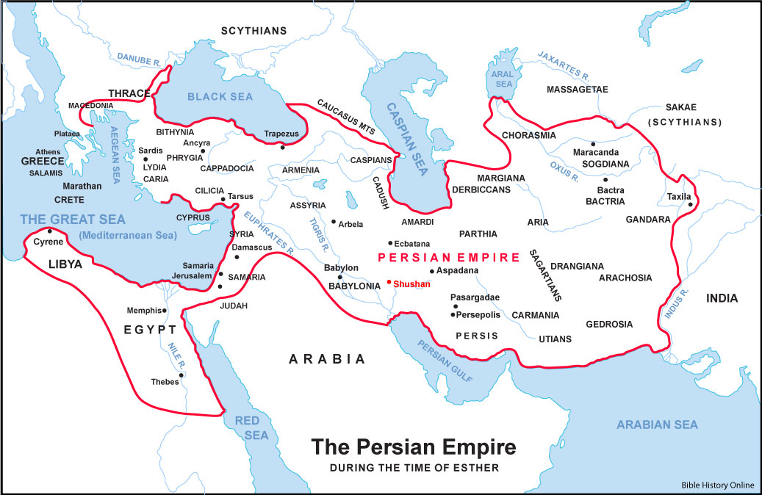
² in those days as King Ahasuerus sat on his royal throne which was at the citadel in Susa, ³ in the third year of his reign he gave a banquet for all his princes and attendants, the army officers of Persia and Media, the nobles and the princes of his provinces being in his presence. ⁴ And he displayed the riches of his royal glory and the splendor of his great majesty for many days, 180 days.

Luxury was the characteristic of the Eastern monarchs, and particularly of the Persians. In their feasts, which were superb and of long continuance, they made a general exhibition of their wealth, grandeur, etc., and received the highest praise from their poets and flatterers.

⁵ When these days were completed, the king gave a banquet lasting seven days for all the people who were present at the citadel in Susa, from the greatest to the least, in the court of the garden of the king's palace. ⁶ There were hangings of fine white and violet linen held by cords of fine purple linen on silver rings and marble columns, and couches of gold and silver on a mosaic pavement of porphyry, marble, mother-of-pearl and precious stones. ⁷ Drinks were served in golden vessels of various kinds, and the royal wine was plentiful according to the king's bounty. ⁸ The drinking was done according to the law, there was no compulsion, for so the king had given orders to each official of his household that he should do according to the desires of each person. ⁹ Queen Vashti also gave a banquet for the women in the palace which belonged to King Ahasuerus.
¹⁰ On the seventh day, when the heart of the king was merry with wine, he commanded Mehuman, Biztha, Harbona, Bigtha, Abagtha, Zethar and Carkas, the seven eunuchs who served in the presence of King Ahasuerus, ¹¹ to bring Queen Vashti before the king with her royal crown in order to display her beauty to the people and the princes, for she was beautiful. ¹² But Queen Vashti refused to come at the king's command delivered by the eunuchs. Then the king became very angry and his wrath burned within him.

Here we have a drunk powerful king with his gang and now tells his servants go get the queen dress her up or some may have said not to… and bring her out so we can admire her beauty.
Drunk people do stupid things

I have no problem with people having a drink but to get drunk or to cause someone to stumble that I believe is when we cross the line over to sin.

¹³ Then the king said to the wise men who understood the times—for it was the custom of the king so to speak before all who knew law and justice ¹⁴ and were close to him: Carshena, Shethar, Admatha, Tarshish, Meres, Marsena and Memucan, the seven princes of Persia and Media who had access to the king's presence and sat in the first place in the kingdom— ¹⁵ "According to law, what is to be done with Queen Vashti, because she did not obey the command of King Ahasuerus delivered by the eunuchs?" ¹⁶ In the presence of the king and the princes, Memucan said, "Queen Vashti has wronged not only the king but also all the princes and all the peoples who are in all the provinces of King Ahasuerus. ¹⁷ "For the queen's conduct will become known to all the women causing them to look with contempt on their husbands by saying, 'King Ahasuerus commanded Queen Vashti to be brought in to his presence, but she did not come.' ¹⁸ "This day the ladies of Persia and Media who have heard of the queen's conduct will speak in the same way to all the king's princes, and there will be plenty of contempt and anger. ¹⁹ "If it pleases the king, let a royal edict be issued by him and let it be written in the laws of Persia and Media so that it cannot be repealed, that Vashti may no longer come into the presence of King Ahasuerus, and let the king give her royal position to another who is more worthy than she.

Never make a decision under the influence.

Now here is a bunch of drunk guys telling the king what he should do to his queen because she refused to be paraded in front of a bunch of drunk people. They are about to go from bad to worse.

²⁰ "When the king's edict which he will make is heard throughout all his kingdom, great as it is, then all women will give honor to their husbands, great and small."

²¹ This word pleased the king and the princes, and the king did as Memucan proposed. ²² So he sent letters to all the king's provinces, to each province according to its script and to every people according to their language, that every man should be the master in his own house and the one who speaks in the language of his own people. Esther 1:1-22 (NASB)

Esther 2
¹ After these things when the anger of King Ahasuerus had subsided, he remembered Vashti and what she had done and what had been decreed against her. ² Then the king's attendants, who served him, said, "Let beautiful young virgins be sought for the king.

Regrets have you ever made a decision under extreme stress or under the influence and later on come to regret it? Ask God first…then make a decision
³ "Let the king appoint overseers in all the provinces of his kingdom that they may gather every beautiful young virgin to the citadel of Susa, to the harem, into the custody of Hegai, the king's eunuch, who is in charge of the women; and let their cosmetics be given them. ⁴"Then let the young lady who pleases the king be queen in place of Vashti." And the matter pleased the king, and he did accordingly.
⁵ Now there was at the citadel in Susa a Jew whose name was Mordecai, the son of Jair, the son of Shimei, the son of Kish, a Benjamite, ⁶ who had been taken into exile from Jerusalem with the captives who had been exiled with Jeconiah king of Judah, whom Nebuchadnezzar the king of Babylon had exiled. ⁷ He was bringing up Hadassah, that is Esther, his uncle's daughter, for she had no father or mother. Now the young lady was beautiful of form and face, and when her father and her mother died, Mordecai took her as his own daughter.

⁸ So it came about when the command and decree of the king were heard and many young ladies were gathered to the citadel of Susa into the custody of Hegai, that Esther was taken to the king's palace into the custody of Hegai, who was in charge of the women.

- God has a plan for you.
Esther had no choice in the matter it says here she was taken. God, my God, doesn’t take you He gives you a choice to follow. At times He will let adversity come into your life and you choose to either turn to Him or turn away from Him.

Look at Esther, she was an orphan adopted by her uncle and God had great plans for her.

But know this God has a plan for your life and how long it takes for that plan to develop can depend on your obedience.

⁹ Now the young lady pleased him and found favor with him(Hegai). So he quickly provided her with her cosmetics and food, gave her seven choice maids from the king's palace and transferred her and her maids to the best place in the harem. ¹⁰ Esther did not make known her people or her kindred, for Mordecai had instructed her that she should not make them known. ¹¹ Every day Mordecai walked back and forth in front of the court of the harem to learn how Esther was and how she fared.

¹² Now when the turn of each young lady came to go in to King Ahasuerus, after the end of her twelve months under the regulations for the women—for the days of their beautification were completed as follows: six months with oil of myrrh and six months with spices and the cosmetics for women—

One year to get them looking good? Wow I’m glad my wife looks so good it only takes her 20 minutes and even at that I tell her that even without make up she looks good.

¹³ the young lady would go in to the king in this way: anything that she desired was given her to take with her from the harem to the king's palace. ¹⁴ In the evening she would go in and in the morning she would return to the second harem, to the custody of Shaashgaz, the king's eunuch who was in charge of the concubines. She would not again go in to the king unless the king delighted in her and she was summoned by name.

¹⁵ Now when the turn of Esther, the daughter of Abihail the uncle of Mordecai who had taken her as his daughter, came to go in to the king, she did not request anything except what Hegai, the king's eunuch who was in charge of the women, advised. And Esther found favor in the eyes of all who saw her. ¹⁶ So Esther was taken to King Ahasuerus to his royal palace in the tenth month which is the month Tebeth, in the seventh year of his reign.

¹⁷ The king loved Esther more than all the women, and she found favor and kindness with him more than all the virgins, so that he set the royal crown on her head and made her queen instead of Vashti.

Queen! God had a plan for her that she didn’t even know about yet.

¹⁸ Then the king gave a great banquet, Esther's banquet, for all his princes and his servants; he also made a holiday for the provinces and gave gifts according to the king's bounty. ¹⁹ When the virgins were gathered together the second time, then Mordecai was sitting at the king's gate. ²⁰ Esther had not yet made known her kindred or her people, even as Mordecai had commanded her; for Esther did what Mordecai told her as she had done when under his care.

²¹ In those days, while Mordecai was sitting at the king's gate, Bigthan and Teresh, two of the king's officials from those who guarded the door, became angry and sought to lay hands on King Ahasuerus. ²² But the plot became known to Mordecai and he told Queen Esther, and Esther informed the king in Mordecai's name. ²³ Now when the plot was investigated and found to be so, they were both hanged on a gallows; and it was written in the Book of the Chronicles in the king's presence. Esther 2:1-23 (NASB)

- God’s plans are always good. They are not harmful to us.
- God’s plans are always designed for our good. For our future.
How can I handle the major decisions in life? How do I know if I’m making decisions that will be good for my family?

- Ask!
But if any of you lacks wisdom, let him ask of God, who gives to all generously and without reproach, and it will be given to him. James 1:5 (NASB)

- Be faithful right where you are!
"His master said to him, 'Well done, good and faithful slave. You were faithful with a few things, I will put you in charge of many things; enter into the joy of your master.' Matthew 25:21 (NASB)

- Listen.
Keep doing your devotions, keep praying because God’s word never changes and He will not tell you to do something out of His character or that is unrighteous.

Trying to make a decision without God’s guidance is like trying to go fishing on a dark night without a flashlight.

"For I, the LORD, do not change; therefore you, O sons of Jacob, are not consumed.
Malachi 3:6 (NASB)
Every good thing given and every perfect gift is from above, coming down from the Father of lights, with whom there is no variation or shifting shadow. James 1:17 (NASB)

- Wait.
But as for me, I will watch expectantly for the LORD; I will wait for the God of my salvation. My God will hear me. Micah 7:7 (NASB)
Speaking for himself and the godly remnant mentioned throughout the book, Micah said that even though the nation was in terrible shape he would continue to watch and wait in hope for the Lord.
Sometimes God gives us more than one good choice and waiting gives us time to pray, think and listen for the wisdom we asked for, that God has promised us.

