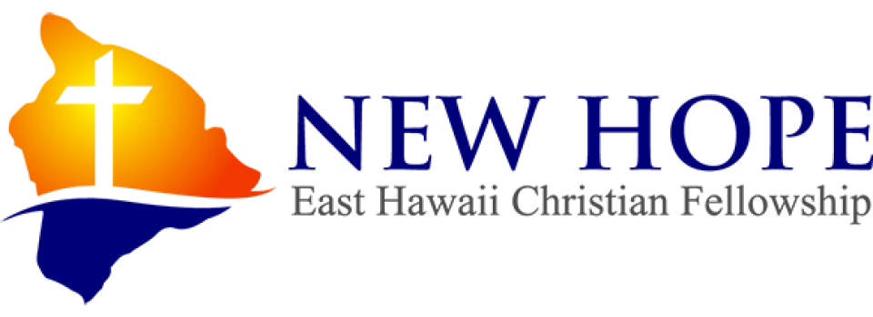

- Financial Peace University
FINANCIAL PEACE
University

Come join us for an online Workshop …
Ramsey’s Financial Peace University is a nine lesson course that teaches you how to save for emergencies, pay off debt fast, spend wisely, and invest for your future. For over 25 years, Dave Ramsey has been teaching commonsense, Biblical money principles that work.

1st and 3rd Saturday at 9:00-10:30am

To join us, please email your name and phone number to kwee0727@gmail.com. $99 fee for Class materials, minimum of 10 families. If you prefer you may text me your info: John Kwee (808) 937-7904

